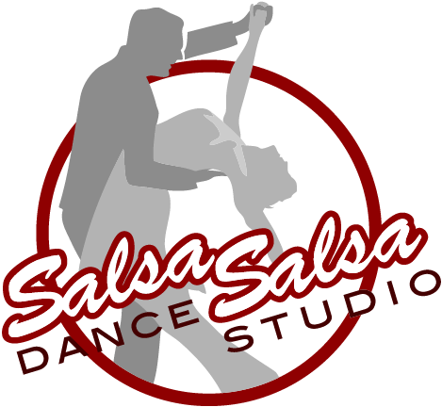 Salsa Salsa Dance Studio
Shine List

Level 1  Four Corners  Angle Basic Cross Side Step  Right Hand Turn  Suzy - Q  Left Hand Turn  Back Steps  Broken Left Turn  Side Basic  Hip Walks  Front & Back Crossovers  Transition Step  Cord Beat Basic  Half Right-Half Left  Slave Step  Slow Slave  Lazy Mambo  Circular Suzy - Q  Traveling Suzy - Q  Cuban Step  Cuban Charge  Double Cross  Hooks  Broken Left Broken Right  Zig - Zag  Side Jerks  Angle Suzy Q  Suzy Q Plus  Left Leg Taps  Double Tap Sailor  Hip Circles  Spiral Kick  Spiral Tap  Reverse Spiral  Back 2 Back Spiral  Traveling Spiral  Kick Turn Step  Suzy Q Cross Suzy Q  Downtown Uptown  Hook Semi Circles  Forward Spiral | Level 2  Heel Taps  Bounce  Front Double Tap  Inside Steps  Hook Flicks  Cha Cha Walks  1 Point Freeze  Front & Back Crossover Suzy Q  Shoe Taps  Half Flare  Swing Steps  Forward Spiral Cha Cha Walks  Slide Crossovers  Double Turn  Full Flare  Front & Back Crossover w/Slide  Cuban Half & Half  Diamond & Pearls  Hot Toe  Angle Swings  Double Cross Flicks  Kick Toe Step  Braided Step  Hunts Point  Mambo Jazz  Grapevine Step  Fancy Flare  Forward Spiral Reverse Flare  Back & Forward Spiral Taps  Four Corner Swing  Left Flare Double Cross  Cuban Reverse  Toe Heel Struts  Toe Heel Step  Toe Heel w/ Slide | Level 3  Cuba Cuba  V-Tap Step  Millie Donay  Syncopated Pulse  Turning Cubans  Heel-Heel Toe-Toe  Reverse Cuba Cuba  Triple Pivot  Studder Step  Front Double Tap w/Slide Circular Swings  Syncopated Double Cross  Traveling Studder  Toe Heel - Toe Turn  2 Point Freeze  Heel-Heel Toe-Toe Crossover  Super Cuba Cuba  Grapevine Turning Toe Heel  Single Rt/Single Lt/Dbl Rt  Pivot Swivel  3 Point Freeze  Dbl Flick Kick & Tap  Flick Tip & Tap  Reverse Toe-Heel Grapevine  Hook Side Triplets  Stop Drop & Roll  Cross Tap Flick Tap  4 Point Freeze  Mood Swings  Double Side Slide  Cross Tap Syncopation  Flick & Rise  Dbl Flick Braid  Cord Crossover Syncopation  Tell It To The Judge | Level 4  Syncopated Papa  A Little Bit of James Brown  Spiral Gyro  Syncopated Spiral Dbl Cross  Tee-Bee-Dee Ta-Ba-Dee  Toe Heel Tornado  Bus Stop  No Yoke  Syncopated V-Tap Hop  Revolving Doors  The Vitamin Step  Jet Lag  Ku-Tu Kum-Pla  285 Knee Gyro  Flying Scissors  Syncopated Shuffle  Flicking 8's  Flick Puzzle  Quick Slick  Dollars & Cents  Sycopated Cut-Away Grapevine  Angle Chicklet  Pop Goes The Weasel

